**State of Illinois**

**Flood Damage**

**Assessment Packet**

A cooperative effort by:

Illinois Department of Natural Resources / Office of Water Resources

Illinois Emergency Management Agency

Federal Emergency Management Agency

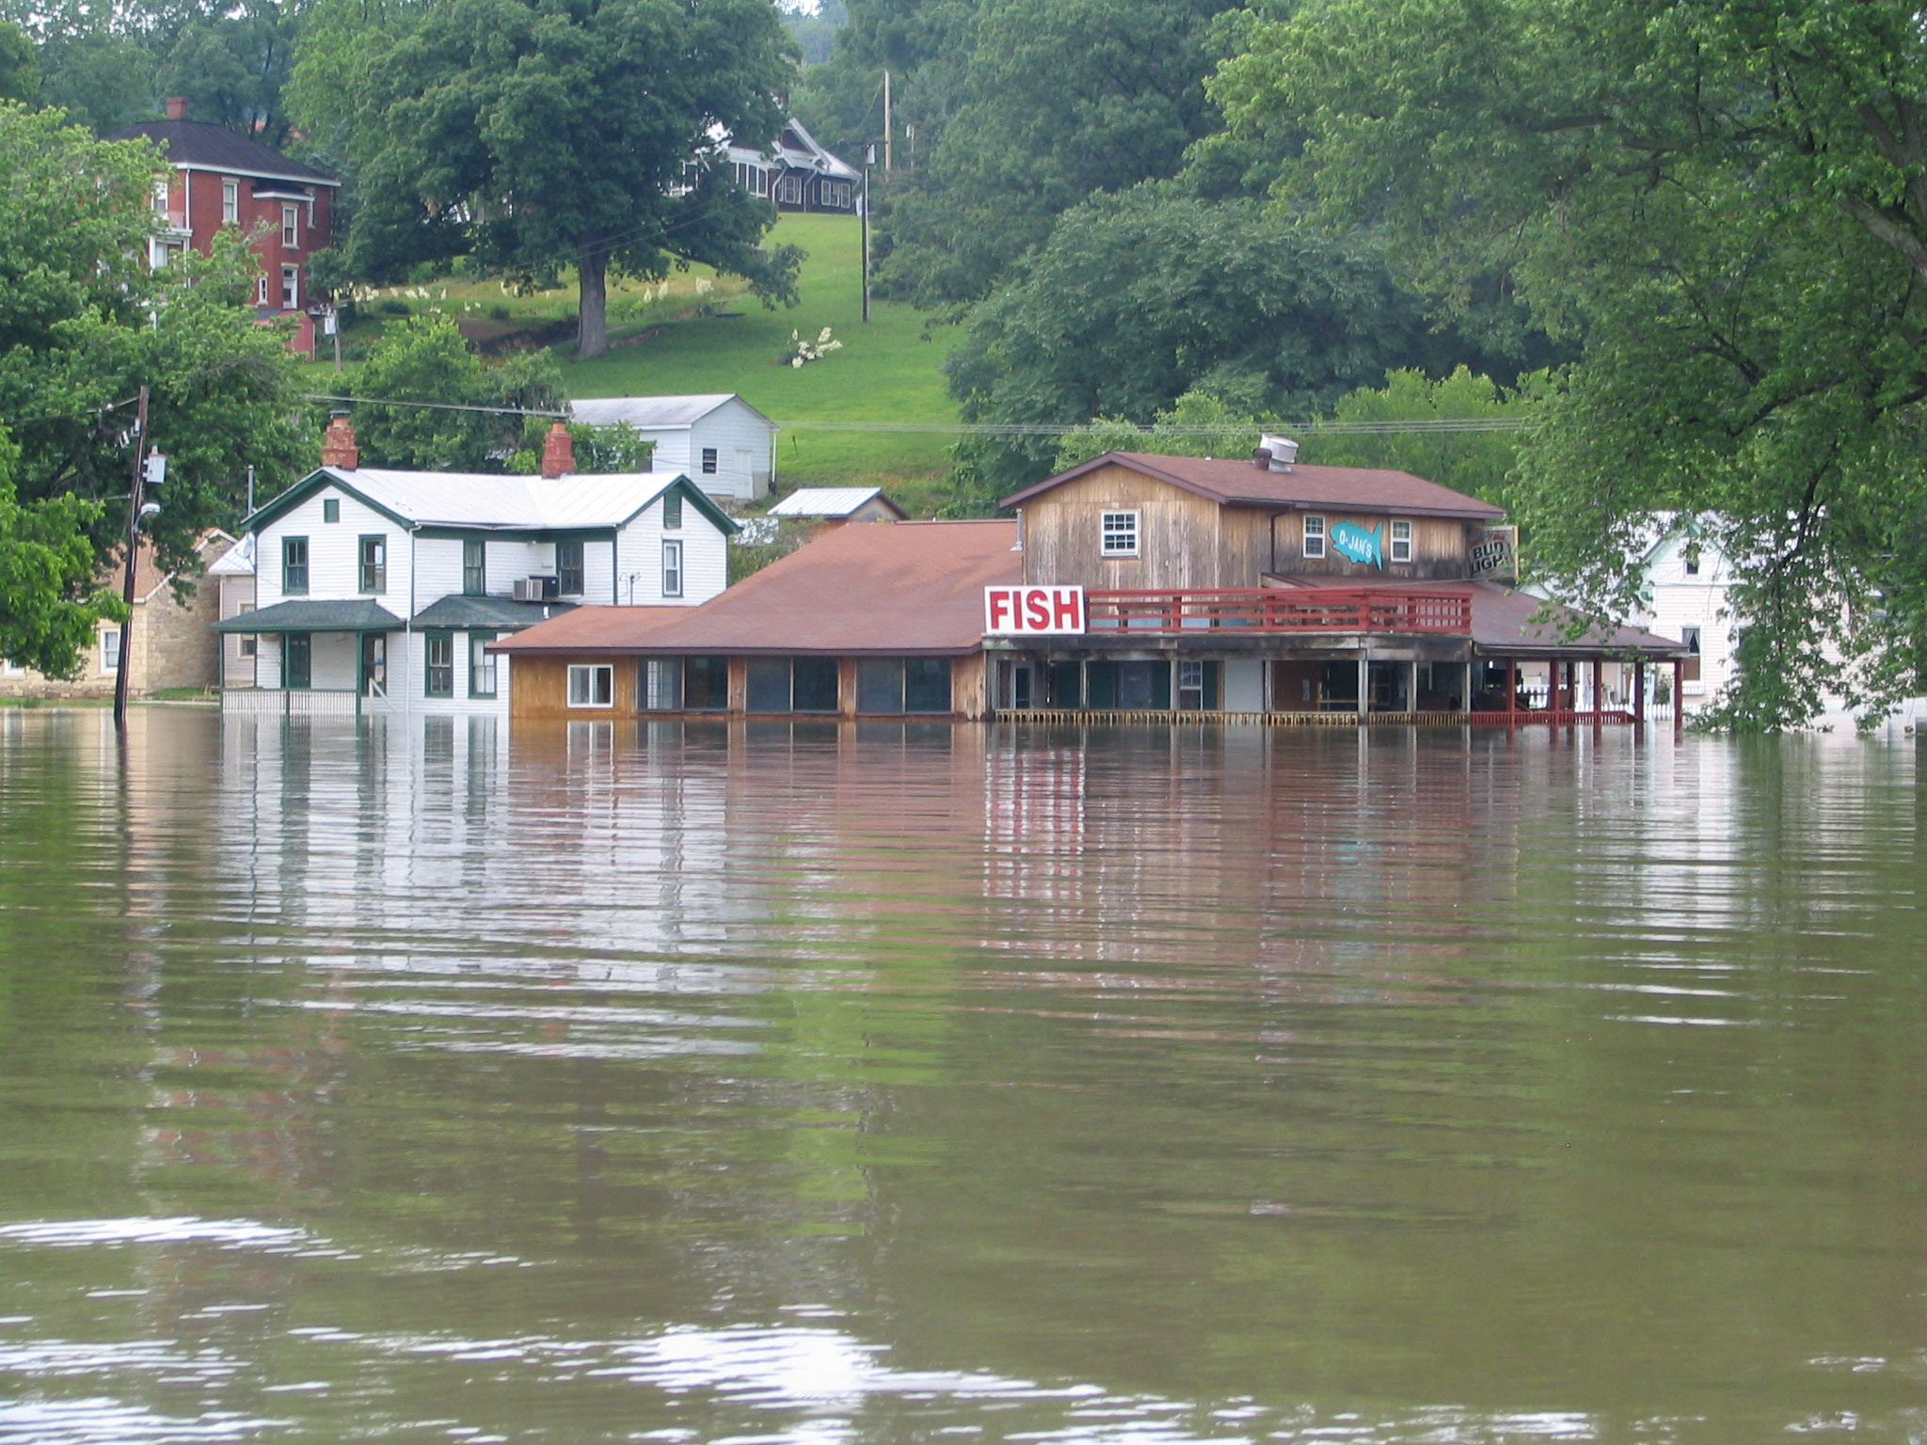

March 2020

Includes Information On:

Steps to Take Following a Flood

Substantial Damage Determinations

Damage Assessment Worksheet

FEMA Substantial Damage Estimator (SDE)

Sample Building Notice

Sample Substantial Damage letter

Sample Press Release

Information on mitigation programs



**STEPS TO TAKE FOLLOWING A FLOOD**

Your floodplain ordinance requires permits for the repair or reconstruction of flood damaged structures. The local administrator must ensure that the repair of a damaged structure meets the floodplain permit requirements. If the cost to repair a flood damaged building is more than 50% of the pre-flood market value, the building is SUBSTANTIALLY DAMAGED (see page 2 for additional details). The building cannot be allowed to repair without making changes to reduce future flood damages, such as elevation or even demolition. It is important to find any “substantially damaged” buildings before repairs begin.

Following a flood event, the local administrator should follow these five steps:

**Step 1: Contact Illinois Department of Natural Resources or Federal Emergency Management Agency**  Both offices have experience, materials, and guidance to help you carry out your floodplain management responsibilities. Make use of their help and expertise!

**Step 2: Begin Damage Assessments and Identify Substantially Damaged Structures**

* As soon as possible, take a windshield tour of the floodplain, specifically note buildings with severe damage
* Photograph and map high-water marks
* Identify areas of flood damaged structures on maps for door -to-door damage assessments.
* Begin door-to-door damage assessments using the forms in this packet or FEMA’s Substantial Damage Estimator 3.0 inspections forms and software. Local officials should inspect every flood damaged building in the floodplain and calculate the cost of repairs. Initially target homes believed to be Substantially Damaged. You will also need the pre-flood market value of every flooded structure, which can be quickly estimated from your Assessor’s records.

**Step 3: Post Notices on Damaged Homes and Post Public Notices about Permit Rules** Tag each structure with the notice included in this packet so residents are aware of the post flood permit requirements. Let the public know your local ordinance requirements for obtaining permits for repairs and rebuilding. A sample press release is also included with this packet. Often repairs begin on flooded buildings before the water even recedes from the structure. It is important that this step take place as soon as possible. History shows that information normally spreads very fast among flood victims. Get the word out that permits are required. Post signs, flyers and notices on damaged structures, issue press releases and electronic messages, and mail letters to individual owners.

**Step 4: Provide Technical Support** Educate yourself on the damage assessment process, reconstruction methods, and available mitigation programs. Have your “Floodplain Development Permit Application” in hand and ready to distribute. Keep it simple. Be prepared for residents who are angry that they cannot start immediate repairs.

After a flood is the perfect time to ensure that flood damages do not occur again. Federal or state mitigation programs may be available to help. Contact the Illinois Emergency Management Agency on their mitigation programs and technical guidance. Public meetings can be held in flooded communities to discuss the options available. IDNR/OWR and IEMA can help with these meetings.

**Step 5: Require Permits** At this point you should be ready to issue permits and enforce your floodplain ordinance. Substantially damaged buildings should be “red-tagged” and letters must be sent to property owners declaring that the building is substantially damaged. An example letter is provided in this packet. Permits for a substantially damaged building must show compliance with your regulations. The building must either be elevated, demolished, relocated or floodproofed (non-residential only). Any buildings with less than 50% damage can be issued permits to begin repairs. **Substantial Damage Determinations-“THE 50% RULE”**

Communities participating in the National Flood Insurance Program (NFIP) have adopted, and are expected to enforce, a floodplain management ordinance. New buildings located in a floodplain must be elevated above the base (or 100-year) flood elevation. The same flood protection and elevation regulations also apply to substantially damaged buildings. FEMA’s Substantial Improvement/Substantial Damage Desk Reference can guide you through this process.

**SUBSTANTIAL DAMAGE** Whenever a building located in a mapped floodplain is damaged from any source (flood, fire, wind, or manmade), the community must determine if that structure is substantially damaged. Substantial damage is when the cost of repairs are 50% or more of the structure’s “pre-damaged” market value.

Manufactured homes can be substantially damaged with as little as one foot of flooding. Frame buildings typically take three feet or more of flooding.

If the building is found to be substantially damaged, the structure must be brought into compliance with the floodplain ordinance. In other words, protected from future flooding to at least the base flood elevation like the newly elevated home below.

The cost of repairs must be calculated for full repair to “pre-damaged” condition, even if the owner elects to do less. The total cost of repair includes structural, electrical, HVAC, finish materials, etc., including labor costs.

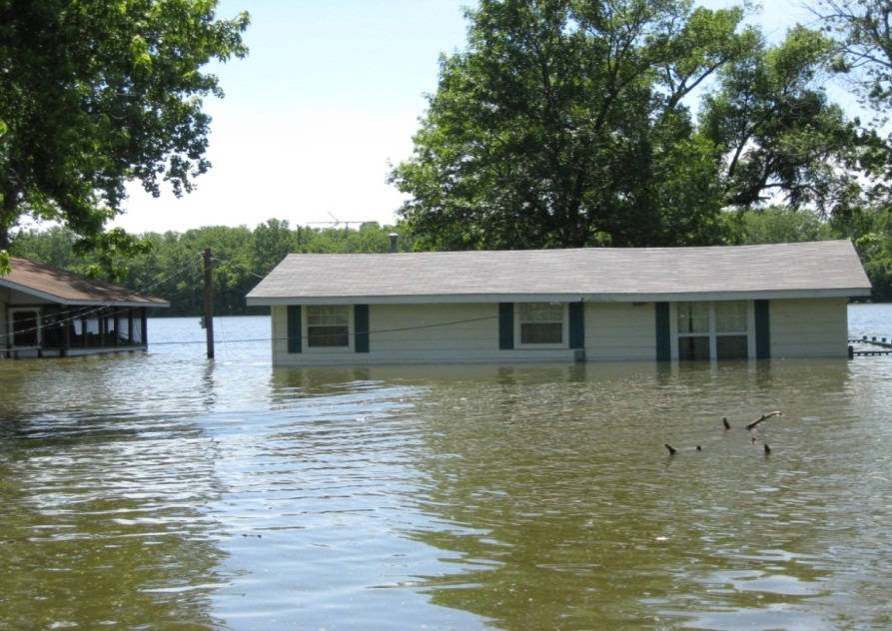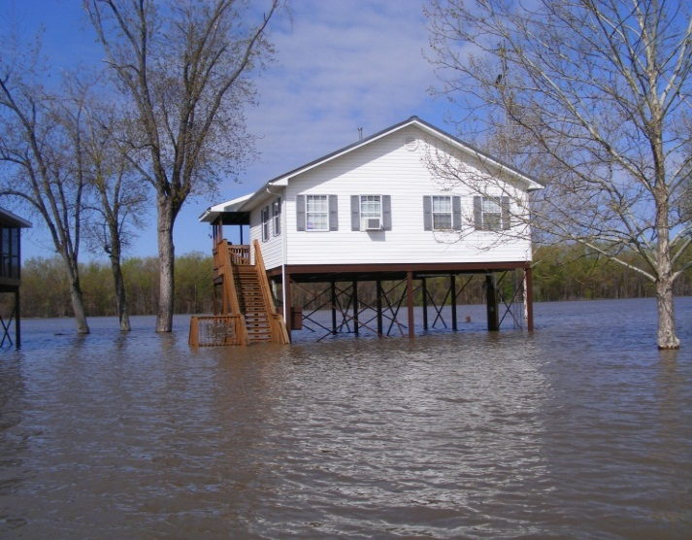

**CUMULATIVE COST** Most communities in Illinois have now adopted ordinances which track cumulative damages and improvements. Cumulative substantial damage or substantial improvement occurs at the point where the sum of the costs for multiple repairs or improvements equal 50% or more than the original market value of the building.

**MARKET VALUE** The market value is for the building only. The value of the land and exterior improvements (pool, landscaping, walkways, etc.) are excluded.

Following a disaster most communities find it easiest and quickest to obtain the assessed value from the County Tax Assessor. Most of the county’s assessments are now online. This ensures a unified market value for everyone (since they have been paying taxes on this figure). Other acceptable methods of estimating market value include:

* Independent appraisals by a professional appraiser for the structure only.
* Detailed estimates of the structure’s Actual Cash Value (replacement cost minus deprecation).
* Property appraisals used for tax purposes.
* The value of the building based on insurance claims.
* Qualified estimates based on sound professional judgment made by staff of the local building department or local or state tax assessor’s office.

**COST OF FLOOD DAMAGE REPAIRS** The cost of repairs must be calculated for full repair to “pre-damaged” condition, even if the owner elects to do less. The total cost of repair includes structural and finish materials as well as labor. If local building codes require the structure to be repaired according to current codes these additional cost must be included in the full repair cost of the structure.

**ITEMS TO BE INCLUDED IN DAMAGE DETERMINTIONS:**

**All structural elements including:**

Foundation footings and pilings

Monolithic or other types of concrete slabs

Bearing walls, tie beams and trusses

Wood or reinforced concrete decking or roofing

Floors and ceilings

Attached decks and porches

Interior partition walls

Exterior wall finishes (e.g. brick, stucco, or siding) including painting and decorative moldings

Windows and doors

Reshingling or retiling a roof

**All interior finish elements, including:**

Tiling, linoleum, stone, hardwood or carpet over subflooring.

Bathroom tiling and fixtures

Wall finishes (e.g. drywall, painting, stucco, plaster, paneling, marble, or other decorative finishes)

Kitchen, utility and bathroom cabinets

Built-in bookcases, cabinets, and furniture

Hardware

**All utility and service equipment. including:**

Heating, ventilating, and air conditioning equipment

Repair or reconstruction of plumbing and electrical services

Light fixtures and ceiling fans

Security systems

Built-in kitchen appliances

Central vacuum systems

Water filtration, conditioning, or recirculation systems

Electrical panel boxes

**Labor and Profit:** The cost of labor, calculated using your county’s prevailing wage rates, are posted on Illinois Department of Labor website. These rates are updated multiple times per year. Profits and any other costs associated with repairing building must be included. The value of volunteer labor or donated materials must be calculated.

**ITEMS TO BE EXCLUDED FROM DAMAGE DETERMINATIONS:**

Plans, specifications, survey and building permits

Demolition costs associated with clean-up, debris removal, and preparation of the site

Structural fill for elevating the building

Plug-in type appliances such as washers, dryers, stoves, refrigerators, window air conditioners, or dehumidifiers.

Detached structures such as garages, gazebos, and sheds

Driveways, fences, sidewalks, yard lights and swimming pools

**DAMAGE ASSESSMENT WORKSHEETS – 3 pages – Attach Photos (Recommended)**

**1. Address**: ______________________________________ **Date of Inspection**:_______________

**2. Owner**:_______________________________________________________________

Telephone/Cell Number ________________________________

**3. Occupant**:___________________________________________________________

Telephone/ Cell Number ___________________________

**4. Insurance Coverage (Optional):**

Company___________________ Policy Number:___________________________

Building: $__________________________ Contents: $______________________

**5. Special Flood Hazard Area:** Community I.D. #:_____________  
 FIRM Panel: _________________ FIRM Date:_____________________  
 Flood zone: __________________ Base Flood Elevation______________(if available)  
 Lowest Floor Elevation: _______________(if available)

Outside ground elevation: ______________________(if available)

Steps to Front Door: ______________

Basement Depth: 8 ft 10 ft Other:__________

**6. Duration of Flooding:** Days___________ Hours _______

**7. High Water Mark/ Flood Depth:**

A) Exterior Walls ____________ ft.

B) Interior Walls Basement/Crawl ___________ ft. First Floor __________ ft.

**8. Type of Structure:**

A) Exterior:

1) Plywood/Hardboard_____ 5) Brick_____

2) Stucco_____ 6) Concrete Block_____

3) Siding/Shingles_____ 7) Other describe)________________

4) Masonry Veneer_____

B) Manufactured/Mobile Home:  
 1) Dimensions: a) Single wide ____ size ______ x______  
 b) Double wide _____ size ______ x______  
 2) Skirting: yes ______ no_______

**9. Description of Structure:**

A) 1 story _______ 2 story ______ Tri-level ______

1 1/2 story _______ Bi-level ______ 3or more ______

B) Garage: Attached________ Detached_______

Carport: Attached________ Detached_______

**Address**: ___________________________

C) Roofing:

Metal/corrugated or ribbed _____ Composition shingles ______

Other: Describe _________________________________________

D) Foundation:

Slab-on-grade **_______**

Crawlspace **_______**

Basement **_______** (Finished Unfinished )

Poured walls _______

Block walls**_______**

Post-piers-piles_______

E) Heating and Cooling:  
 Forced air_______ Boiler ________

Wall furnace or baseboard **_______** Heat Pump______

Fireplace/wood burning stove _______ Other

F) Plumbing:Number of bathrooms: _______

G) Built-In Appliances: List: ______________________________________________________

**10. Description of Damage:**

A) Plumbing: 1) Is it exposed?_______ 2) Does it need repair?_______

B) HVAC

1) Heating -Submerged __Yes No____ Repair _______ or Replace ________

2) AC - Submerged __Yes No____ Repair _______ or Replace ________

2) Ducts - Submerged __Yes No____ Repair _______ or Replace ________

C) Electrical

1) Panel Submerged __Yes No____ Repair _______ or Replace ________

2) Outlets Submerged __Yes No____ Repair _______ or Replace ________

D) Foundation __________________________________________________________

Use following descriptions listed below or describe damage:

1. Settlement/cracked 2. Partially missing 3. Sagging

4. Dislodged/destroyed 5. Submerged 6. All of the above 7. No damage

E) Exterior Walls Water depth: _______ Describe:________________________________

F) Interior Walls Water depth: _______ Describe:________________________________

G) Roof ________________________________________________________________

**11. Overall condition of structure:**

A) Minor damage **_______** B) Major Damage _______

C) Totally destroyed _______ D) Structure off foundation ______

**Address**: ___________________________

**12. Cost of Repair - The following table includes building elements typically damaged by floods for residential buildings. Enter N/A as appropriate for non-residential.**

Source: ______________________________________________________________________________

|  |  |  |  |
| --- | --- | --- | --- |
| **Item** | **Estimated Cost to Repair** | **Item** | **Estimated Cost to Repair** |
| **Foundation** |  | **Plumbing** |  |
| **Exterior (finish, framing, wall, insulation, etc.)** |  | **Electrical** |  |
| **Interior (walls and finish)** |  | **Furnace** |  |
| **Doors** |  | **Water Heater** |  |
| **Windows** |  | **A/C Condenser** |  |
| **Cabinets and Countertops** |  | **HVAC Ducts** |  |
| **Flooring Coverings** |  | **Skirting/Piers (Man Homes Only)** |  |
| **Built-in Appliances** |  | **Other** |  |
| **Hardware** |  | **Subtotal** |  |
| **Subtotal** |  | **TOTAL** |  |

**13. Market Value**

Source: ______________________________________________________________________________

Market Value of Building: __________________

**14. Determination of Substantial Damage**

Cost of Repair

Percent Damage = --------------------------- ---- = ____________________

Market Value of Building

If the percent damage is equal to or greater than 50%, the building is **substantially damaged**.

_______ This building is **substantially damage**d and therefore must be elevated or floodproofed (non-residential) so that the lowest floor is protected at or above the elevation of the base flood.

_______ This building is not substantially damaged. This building can be repaired without requiring mitigation.

_______ This is a properly elevated structure and may be repaired at its existing elevation.

_______ The structure is elevated but modifications, such as proper flood openings are required:

_______________________________________________________________________________________

Reviewed by:____________________________________ Date:________________

Approved by:____________________________________ Date:________________

**FEMA SUBSTANTIAL DAMAGE ESTIMATOR (SDE)**

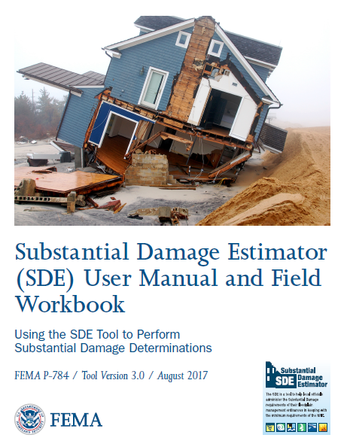

FEMA has developed a computer program called the Substantial Damage Estimator (SDE) to assist local officials estimate building value and damage costs. If your community has multiple structures that have been flooded, it is definitely worth your time to obtain the SDE and learn to use the program. It will save you time, research and help keep your estimates uniform.

The program can be downloaded from FEMA’s website at: <https://www.fema.gov/media-library/assets/documents/18692>

or contact IDNR for assistance.

You will also need to download the following:

* [SDE Read Me – SDE 3.0 Tool Installation Guide.pdf](https://www.fema.gov/media-library-data/1504291573550-a6fa57343ca6740b8cfcb4c609b599f7/SDE_Read_Me_-_SDE_3.0_Tool_Installation_Guide.pdf)
* [FEMA P-784, Substantial Damage Estimator (SDE) User Manual and Field Workbook: Using the SDE Tool to Perform Substantial Damage Determinations (August 2017),](https://www.fema.gov/media-library-data/1504291725295-a6fa57343ca6740b8cfcb4c609b599f7/SDE_3.0_User_Manual_and_Field_Workbook.pdf)
* [FEMA Substantial Damage Estimator Best Practices (August 2017)](https://www.fema.gov/media-library-data/1504291573723-a6fa57343ca6740b8cfcb4c609b599f7/SDE_Best_Practices.pdf)

The program is based on regulatory requirements of the NFIP and is intended to be used in conjunction with an industry accepted residential cost estimating guide (such as the Marshall-Swift or RS Means Guide).

The SDE User Manual and Field Workbook is essential for helping you properly use the tool. The workbook includes both [residential inspection worksheets](https://www.fema.gov/media-library-data/1504291573444-a6fa57343ca6740b8cfcb4c609b599f7/1._Residential_Damage_Inspection_Worksheets.pdf) and [non- residential inspection worksheets](https://www.fema.gov/media-library-data/1504291573490-a6fa57343ca6740b8cfcb4c609b599f7/2._Non-Residential_Damage_Inspection_Worksheets.pdf) that mirror the data entry required by the computer program.

**ILLINOIS DAMAGE ASSESSMENT CHEAT SHEET**

The SDE requires the inspector to estimate the percent of damage for various building components. The information compiled below can be used with the SDE worksheet for residential buildings, quickly calculating substantial damage. It is intended to be used as a screening tool so that the property owner is notified as soon as possible as to the potential status of his property. Often a more detailed assessment is warranted, and more detailed damage percentages should be determined on an as-needed basis.

|  |  |  |  |  |  |  |  |  |  |  |
| --- | --- | --- | --- | --- | --- | --- | --- | --- | --- | --- |
|  | **Super-structure** | **Exterior Finish** | **Interior Finish** | **Doors and Windows** | **Cabinets**  **and Counters** | **Flooring** | **Plumbing** | **Electrical** | **Built in Appliances** | **HVAC** |
| **FLOODDEPTH** |  |  |  |  |  |  |  |  |  |  |
| **1 – 3 Inches** | 10 | 0 | 0 | 0 | 0 | 100 | 0 | 0 | 0 | 0 |
| **0.5 feet** | 10 | 5 | 5 | 10 | 20 | 100 | 0 | 0 | 0 | 0 |
| **1 foot** | 10 | 10 | 10 | 15 | 50 | 100 | 20 | 0 | 50 | 80 |
| **2 foot** | 10 | 30 | 30 | 40 | 50 | 100 | 30 | 20 | 100 | 80 |
| **3 foot** | 25 | 40 | 40 | 40 | 50 | 100 | 30 | 30 | 100 | 80 |
| **4 foot** | 25 | 50 | 50 | 75 | 70 | 100 | 30 | 60 | 100 | 80 |
| **>5 foot** | 50 | 50 | 100 | 100 | 100 | 100 | 50 | 80 | 100 | 80 |
| **Two story =** | * | * | * | * |  | * | ** | ** |  |  |

**For two story buildings the percentage for each building element is typically reduced as follows:**

**\* = Reduce by 40 – 50% for two story home**

**\*\* = Reduce by 25% for two story home**

**For split-level buildings use your best judgement for any adjustments to the damage percentages**

**Foundation**

Basement or crawlspace:

10% minor clean up, re-seal, paint, etc.

50% if cracked bowed or fractured on one or more walls

100% if structural damage such as blow out or caved in walls

Slab on Grade

10% damage unless the foundation is undermined

30% if foundation is undermined

75% if foundation is broken or bowed or uplift

**SAMPLE HANDOUT FOR RESIDENTS**

**INSERT COMMUNITY LETTERHEAD**

**Information Regarding Cleanup of Damaged Structures within the Floodplain.**

Repairs to damaged buildings located within the floodplain require a permit from the building department and/or the Floodplain Administrator.

1. You **MUST** obtain a building permit before you repair, alter, or replace any of the following items:
   1. Roof
   2. Walls
   3. Siding
   4. Plaster
   5. Cabinets
   6. Flooring
   7. Electrical systems
   8. Plumbing
   9. Heating
   10. Air conditioning units
   11. Foundation
2. The permit office must conduct a damage assessment of the building. This inspection will determine if a structure is more than 50% damaged (Substantially Damaged). If a structure is found to be substantially damaged, the structure may not be repaired until it meets current flood protection requirements. It is imperative that the community permit office is contacted prior to taking any actions to repair damage related to the flood.
3. You may proceed with cleanup activities and temporary emergency repairs to prevent further deterioration, such as preventing the spread of mold and/or mildew, without a permit. These include:
   1. Removing and disposing of damaged contents, carpeting, wallboard, and insulation.
   2. Hosing and scrubbing, or cleaning floors, walls, and ductwork.
   3. Covering holes in roofs or walls and covering windows to prevent the weather from inflicting further damage.
   4. Removing sagging ceilings, shoring up broken foundations, and other actions to make the building safe to enter.

Prior to proceeding with cleanup activities that are allowed without a permit, you should thoroughly document the condition of the building by photographing the inside and outside of all areas that are being affected by the cleanup/emergency repairs.

**NOTE: BUILDING REPAIRS AND STRUCTURAL IMPROVEMENTS**

**ARE NOT ALLOWED WITHOUT A PERMIT.**

**THE BUILDING DEPARTMENT IS OPEN FROM __________________________.**

**CALL AHEAD FOR APPOINTMENTS**

**QUESTIONS, PLEASE CONTACT ___________________________ AT ______________________.**

**SAMPLE PRESS RELEASE**

**RESIDENTS IN (COMMUNITY) WITH FLOOD DAMAGE REMINDED OF PERMIT REQUIREMENTS**

As property owners in (community) begin clean-up and repairs following recent flooding, the (community permit office) is reminding residents to obtaining permits before repairing or rebuilding flood-damaged structures.

Permits must be obtained for any construction or development activity in a floodplain area, including the repair or reconstruction of structures damaged by flooding.

Special conditions apply to buildings in which the total cost of repairs is 50 percent or more of the structure’s pre-flood market value. If a building is found to be damaged 50 percent or more, regulations require that repairs not begin until compliance with the local floodplain ordinance is demonstrated. In some cases, that may require elevating or flood-proofing the structure to reduce the potential for future flood damage.

Repair costs must be calculated by assuming the building will be fully repaired to its pre-damaged condition, even if the owner decides to do less. The total cost calculation must include structural materials, finish materials and labor, even if the owner chooses to do his or her own repairs. The (community) also tracks cumulative damages caused by multiple flood events.

State and federal assistance may be available to property owners to reduce the chances of future flood damage. Mitigation assistance may cover costs of relocation, or for elevating or purchasing flood-damaged structures. Residents with a flood insurance policy may also be eligible to obtain up to $30,000 to protect a structure from future flood damage.

Property owners and residents with flood-damaged buildings should contact (local building and zoning administrator) for more information on repair and reconstruction permits.

**SAMPLE DAMAGE DETERMINATION LETTER**

06/12/2000

John & Jane Q. Public

1234 Flooded-By-The-River Rd.

Deepwater Il 61000

RE: Substantial Damage

1234 Flooded-By-The-River Rd.

Dear Mr. And Mrs. Public,

Subsequent to the recent flooding event, a damage assessment has been completed on the property referenced above. This is a part of _____(insert community name)________ ’s floodplain management responsibilities in order to maintain the availability of flood insurance and disaster assistance to residents. The following information relates to the address referenced above:

Community Number: 170XXX

Parcel Zone Information: Zone A

Fair Market Value of structure: $31,226 (based on 3.3 x assessed value)

Flood Damage:

June 2008 **$18,864**

Total damages $18,864

Percent Damaged: 60.4% damage due to flooding

Ordinance Requirement: Mitigation (elevation, removal)

The determination is that this structure is declared **Substantially Damaged** due to flooding and must be brought into compliance with the ___(insert community name)_____ Floodplain Ordinance prior to repair and reoccupation. For this structure to be in compliance with the ordinance, the structure must be elevated, moved outside the floodplain or demolished.

Building inspections, Building Permits, and an **Elevation Certificate** will be required prior to the issuance of a *Certificate of Occupancy*. This structure may **NOT** be occupied until these corrections are made. Please contact this office at your earliest convenience to make an appointment with me to discuss your upcoming project. If you have any additional questions, you may feel free to give me a call at xxx-xxxx.

Sincerely,

Your Name and title

**SAMPLE NOTICE TO POST ON STRUCTURES**

**NOTICE**

**Because this building is located in a floodplain and was damaged by flooding, a damage assessment must be conducted by the (village or county).**

**Before occupying this building or doing any repair work you must call the (village or county) Department of Zoning and Building Safety at (___ ) _________ to schedule and inspection.**

**Failure to obtain reconstruction approval may result in a penalty.**

**Need Help with Damage Assessments?**

**The Illinois Association for Floodplain and Stormwater Management (IAFSM)**

**Rapid Assistance Flood Team (RAFT) may be your answer**

Every year, flooding occurs somewhere in Illinois. Often, the local floodplain manager will be overwhelmed following a flood. Illinois is blessed with some of the best floodplain managers in the entire nation. These experts can help communities following a flood.

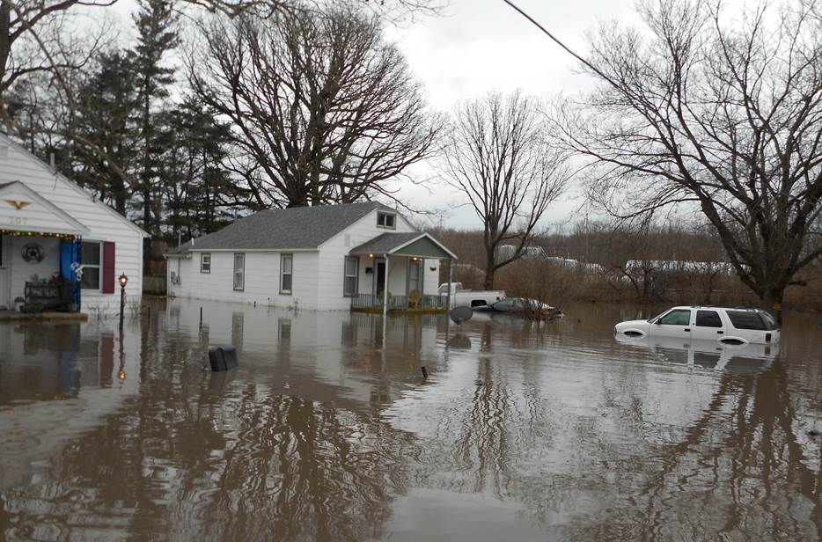

The purpose of the IAFSM Rapid Assistance Flood Team (RAFT) is to assist communities in times of flooding or other natural disasters.

Members of the RAFT are all active in the IAFSM. Members are all Certified Floodplain Managers. They represent local, state and federal government, the private sector, and other professional disciplines. RAFT members all have experience and training in post-flood responsibilities. RAFT members are all volunteers and have agreed to assist other communities in times of need.

**RAFT Assistance Requests**

Local officials who need help with post flood damage assessments can request RAFT members through the IAFSM Floodplain Management Chair. The IAFSM can provide a fill-in-the blank request letter. This letter will also serve as a release of liability for the community and RAFT members.

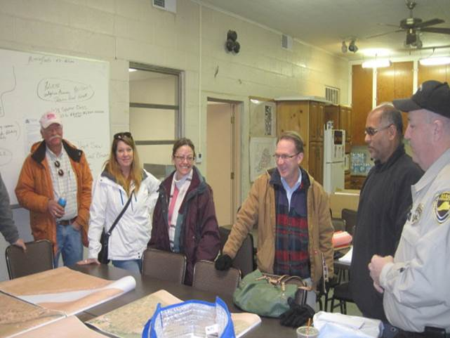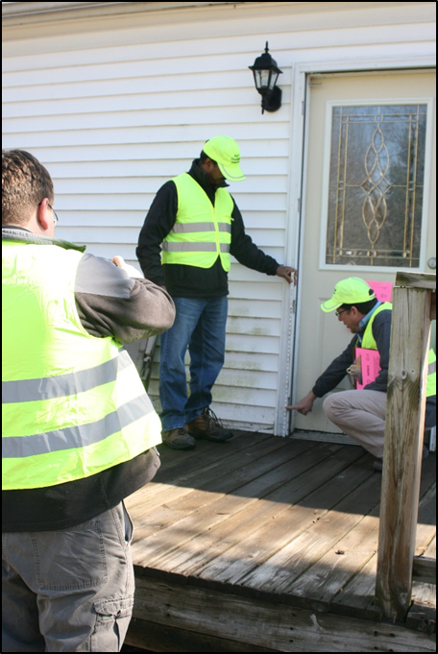

RAFT members are volunteers and can respond based on availability. RAFT volunteers will travel on a work-day basis. There is no charge to the community for travel or per diem and no overnight lodging is assumed.

Requests for assistance should be made to the current IAFSM Floodplain Management Chairman. The IAFSM website is [www.illinoisfloods.org](http://www.illinoisfloods.org).



**July 2011**

**STATE PERMIT FLOOD RECOVERY REGULATORY ISSUES**

Illinois Department of Natural Resources, Office of Water Resources (IDNR/OWR) permits are required only in the floodway portion of jurisdictional streams. Under the Rivers, Lakes and Streams Act (615 ILCS 5), the IDNR/OWR regulates construction within public bodies of water and within floodways of streams in urban areas with drainage areas of one (1) square mile or more and streams in rural areas with drainage areas of ten (10) square miles or more. The floodway is the stream channel and the portion of the adjacent floodplain area that is needed to safely store and convey flood waters. Where floodways have been delineated for regulatory purposes, the mapped lines show the floodway limits and will be used. For cases where a floodway has not been delineated, the whole 100-year frequency floodplain is regulated. The rules and application form may be viewed on and downloaded from our regulatory website: <http://dnr.state.il.us/owr/resman/permitprogs.htm>

PLEASE NOTE: The local community should always be contacted to ensure compliance with local floodplain development requirements.

**Replacing or Repairing Damaged Buildings**

IDNR/OWR permits are required to replace buildings or make modifications to existing buildings which would increase their outside dimensions. An application for permit should be submitted including a completed application form and plans showing the location and dimensions of both the old and proposed buildings. If the footprint of the replacement structure is no larger than that of the old, a permit will be issued soon after receipt of the application. Replacement buildings larger than the old structure may be permissible depending on the size, location and the potential for cumulative adverse affects on the stream’s flood carrying capacity. Those projects will generally require additional data and review time and may not receive approval.

**Raising Existing Buildings**

The raising of existing buildings, provided no changes are made to the outside dimensions of the building and provided the proposed raising would not involve the placement of fill to accomplish the raising, is authorized by IDNR/OWR Statewide Permit No. 6. This and other statewide permits may be viewed at: <http://dnr.state.il.us/owr/resman/permitprogs.htm>. For projects meeting the terms and conditions of a statewide permit, it is not necessary to submit applications to, or receive individual permits from, IDNR/OWR.

**Repair/Replacement of Infrastructure and Other Structures**

If a structure in a public body of water or jurisdictional floodway is to be totally replaced or reconstructed, a permit will be required but will be authorized quickly upon receipt of a completed permit application demonstrating that the structure is being replaced in kind or with a structure that is no more obstructive to river navigation or flood flows. To replace bridge and culvert crossings that have been the cause of demonstrable flood damage, it will need to be demonstrated that the replacement crossing has been designed to reduce the induced flood damages to the fullest practicable extent. IDNR/OWR authorization is not required for the repair of structures that are basically still intact, bridge deck replacement or the replacement of appurtenant navigation structures such as mooring cells at existing barge loading facilities.

**July 2011**

**STATE PERMIT FLOOD RECOVERY REGULATORY ISSUES (cont.)**

**Levee Repair**

Repairs which reestablish the levee to its original alignment and top elevation do not require IDNR/OWR authorization. For any levee work involving a change in the alignment or top elevation, information should be submitted to IDNR/OWR for review and determination of permit requirements. Please provide your name and contact information, a map showing the location of the levee and approximate location of the damaged section(s), any available information on the historic (pre-July 1, 1985), existing and proposed levee profiles and a brief description of the planned repairs.

**Removal of Flood-Deposited Debris and Sediment**

The removal of debris does not require IDNR/OWR authorization, but the material should be disposed outside of the floodway or where it will not obstruct flood flows or be liable to washing into a stream. Flood-deposited sediment may be removed from stream floodways and all previously improved stream channels and drainage ditches without a permit. Statewide Permit No. 11 authorizes maintenance dredging on up to 1,000-foot lengths of natural stream channels and for marinas, barge terminals, water intakes and other public water facilities. This and other statewide permits may be viewed at: <http://dnr.state.il.us/owr/resman/permitprogs.htm>. If the excavated/dredged material is not to be used to restore scoured areas to pre-flood conditions or removed from the floodway, information should be submitted to IDNR/OWR for review and determination of permit requirements. Please provide your name and contact information, a map and drawings showing the locations and dimensions of the sediment deposits and proposed disposal areas.

**Restoration of Altered Streams and Scoured Floodways**

Stream channels that have changed course and floodways that have been scoured as a result of the 2008 floods may be restored to 2008 pre-flood conditions without IDNR/OWR authorization. Additionally, certain channel stabilization and channel maintenance activities are authorized by IDNR/OWR Statewide Permit Nos. 9 & 11. These and other statewide permits may be viewed at: <http://dnr.state.il.us/owr/resman/permitprogs.htm>. Individual permits are required for other channel modification and floodway regrading projects on jurisdictional streams.

**IDNR/OWR Contact Information**

Regulatory Programs Website: <http://dnr.state.il.us/owr/resman/permitprogs.htm>

Telephone: 217/782-3863

Facsimile: 217/785-5014

|  |  |
| --- | --- |
| Fact Sheet | |
|  | Mitigation Information |

**Hazard Mitigation Assistance**

The Federal Emergency Management Agency (FEMA) and state mitigation programs present a critical opportunity to reduce the risk to individuals and property from natural hazards while simultaneously reducing reliance on Federal disaster funds. Mitigation programs can be implemented before, during, and after the flood disaster.



Hazard Mitigation Grant Program



The Hazard Mitigation Grant Program (HMGP) assists in implementing long-term multi-hazard mitigation measures following major disaster declarations. Funding is available to implement projects in accordance with State, Tribal, and local priorities.



Pre-Disaster Mitigation

The Pre-Disaster Mitigation (PDM) program funds are allocated by Congress for an annual competitive application process for hazard mitigation planning and the implementation of mitigation projects. Funding is made available for measures that can be taken to reduce or eliminate overall risk from natural hazards.

Flood Mitigation



Assistance

The Flood Mitigation Assistance (FMA) program makes funds available on an annual basis so that measures can be taken to reduce or eliminate risk of flood damage to buildings insured under the National Flood Insurance Program (NFIP).State IDNR Mitigation Programs/Funds

The Office of Water Resources (OWR) and the Department of Commerce and Economic Development (DCEO) have a long history of funding and completing mitigation projects. State funds are often used to provide cost sharing to compliment Federal mitigation projects.

* State programs are available to any local unit of government
* Communities must be in good standing in the NFIP
* Projects must meet cost benefit criteria.

**What is Mitigation?**  Any sustained action taken to reduce or eliminate long term risk to human life and property from hazards. Mitigation focuses on breaking the cycle of disaster damage, reconstruction, and repeated damage.

**Eligibility Requirements**

All mitigation projects must be cost‐effective, meet both engineering and technical feasibility criteria, and clear Environmental Planning and Historic Preservation requirements in accordance with the Federal Guidance. In addition, all mitigation activities must adhere to all relevant statutes, regulations, and requirements including other applicable Federal, State, Indian Tribal, and local laws, implementing regulations, and Executive Orders.

* NFIP Participation Requirement
* Permanent or long-term solution
* Cost/Benefit Requirement
* Cost Share Requirement
* Environmentally Sound
* Complements State Priorities/ Local Mitigation Plan
* Supported by community
* Strictly Voluntary Participation
* Selected from Competitive process

Please contact your State Hazard Mitigation Officer

Sam Al Basha at (217) 785-9942.

https://www2.illinois.gov/iema/Mitigation/Pages/default.aspx

For additional information visit www.FEMA.gov

or download the Hazard Mitigation Unified Guidance at

www.fema.gov/library/viewRecord.do?id=4225

**Cost Share Requirements**

|  |  |
| --- | --- |
| Program | Mitigation Activity Grant  (Percent Federal/non-Federal) |
| HMGP | Up to 75/25 |
| PDM | Up to 75/25 |
| FMA | Up to 75/25, 90/10, 0r 100% |

**Eligible Activities**

|  |
| --- |
| * Property Acquisition and Structure Demolition or Relocation |
| * Structure Elevation |
| * Mitigation Reconstruction |
| * Dry Floodproofing of Historic Residential Structures |
| * Dry Floodproofing of Non‐residential Structures |
| * Minor Localized Flood Reduction Projects |
| * Structural Retrofitting of Existing Buildings |
| * Non‐structural Retrofitting of Existing Buildings and Facilities |
| * Safe Room Construction |
| * Infrastructure Retrofit |
| * Soil Stabilization |
| * Wildfire Mitigation |
| * Post‐disaster Code Enforcement |
| * 5% Initiative Projects |

Who is Eligible to Apply?

States governments are eligible applicants. Each State government shall designate one agency to serve as the Applicant for each mitigation program. In Illinois, that agency is the Illinois Emergency Management Agency (IEMA). All interested sub applicants must apply to IEMA. Individuals and businesses may not apply directly to FEMA. An approved and adopted Local Mitigation Plan is a prerequisite to apply for Federal mitigation funding.

Requests for state mitigation funding should be made to the

applicable state agency.

**Protect Your Home From Flood Damages**

**Increased Cost of Compliance (ICC)**

In Illinois, it is estimated that there are over 250,000 buildings located in floodplains. Floods are by far the most common natural disaster in Illinois, accounting for well over 90% of the declared disasters. Annual damages due to flooding average nearly $300 million dollars. Unfortunately, much of this flood damage occurs on the same properties over and over again. For this reason, flood insurance coverage now pays to mitigate these properties to reduce the chances of future flooding.

**Increased Cost of Compliance (ICC) Program:**

* provides up to $30,000 in addition to flood insurance claims.
* ICC can be used to floodproof, relocate, elevate, demolish (F.R.E.D.)
* structure must be located in a floodplain

Illinois has the nation’s largest inland system of rivers, lakes and streams

* structure must have a flood insurance policy in effect
* structure must be determined to be substantially damaged (or cumulatively damaged) by flooding beyond 50% of the value of when the damaged occurred.

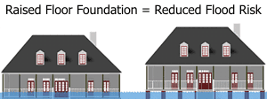

* bring structure into compliance with F.R.E.D

This repetitively flooded home in Rock Island County, Illinois used an ICC claim to reduce the chance of future flooding.

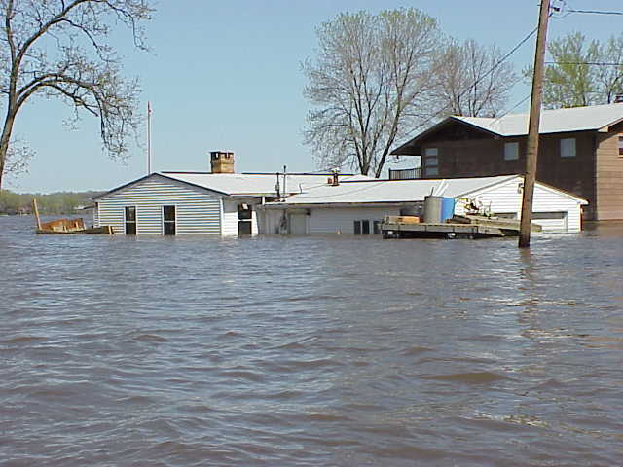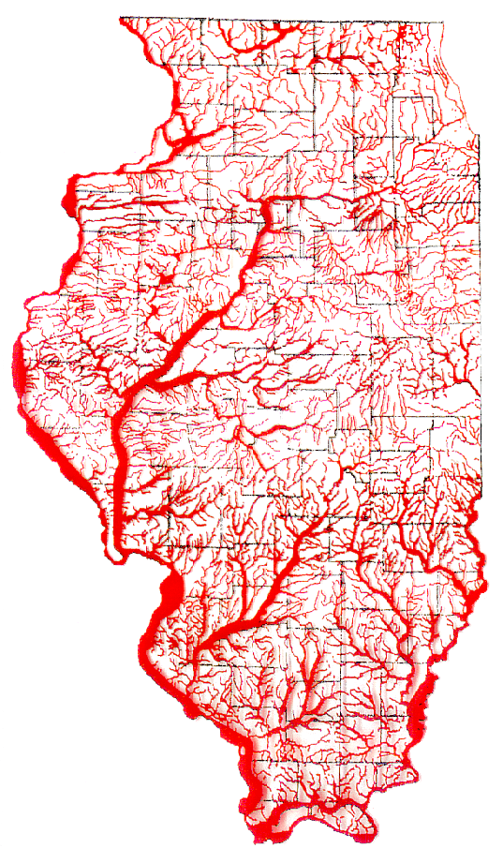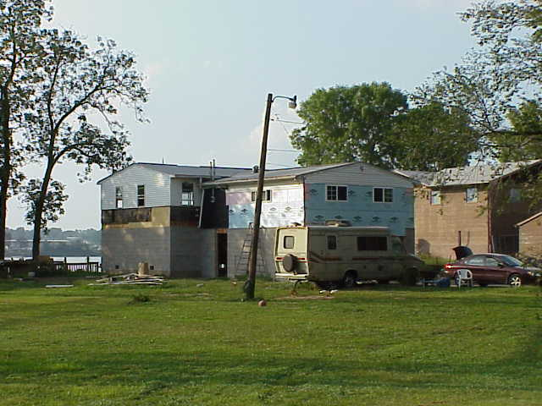

The two most common types of

ICC mitigation used in Illinois are:

Home being moved to higher ground.

**Relocation:**

Relocating structures to higher ground or purchasing flood prone property is the safest way to protect against flooding and reduce the liability and cost to the community.

Relocating initially can be expensive, but in the long run it can be less expensive than repetitive flood damages or high flood insurance premiums

**Elevation:**

Three methods to elevate:

* Constructing on crawlspace,
* Elevating on compacted fill, or
* Elevating on piles or piers.

Elevation method is dependent on the structure’s condition, flood hazard, local floodplain regulations, and owner’s financial condition.

When elevating, it is essential for all utilities (air conditioner, water heater, furnace, etc.) to be elevated at or above the Flood Protection Elevation.

For more information contact the Illinois NFIP Coordinating Office at (217) 782-3863 or

Illinois State Hazard Mitigation Office at (217) 782-8719 or go to:

*https://www.fema.gov/increased-cost-compliance-coverage*

**Home Moving and Elevation Contractors**

**1 Peters House**

**& Building Movers**

R.R. #1 Box 114

Farmer City, IL 61842

(309) 928-2532

**2. MCE Home Movers**

1637 East 800 North Rd.

Loda, IL 60948

[mcemoving@yahoo.com](mailto:mcemoving@yahoo.com)

217-379-2955 – office

217- 519-0244 – cell

**3. Lyle Hyatt and Company**

**House Movers**

612 Green Street

Sandwich, IL

815-786-6591

**4. Balagna House Moving, Inc.**

21529 E. Illinois Highway 116

Farmington, IL 61531

(309) 245-4486

**5. Greene County Steel**

Eldred, IL 62027

(618) 576-9730

**6. Louvier’s Construction Inc.**

1038 Urna Drive

St. Louis, MO 63301

(636) 250-3189

*elevation only

**7. Expert House Movers**

7144 Pershing Avenue

St. Louis, MO 63130

(314) 727-2722

Or

(800) 305-8939

**8. Goodwin House Moving**

2964 Coppock Road

Washington, IA 52353

(319) 653-5644

*This list includes contractors who have done ICC elevation projects in the past. It is not a complete list and does not imply an endorsement by the State of Illinois. Consult your phonebook for local contractors.*

8

