Residential
SDE DAMAGE INSPECTION WORKSHEET
Single-Family, Town or Row House (Site Built Residences), or Manufactured House
Address:
SDE ADDRESS Tab
Subdivision Information
Subdivision: Parcel Number:
Lot Number: Elevation of Lowest Floor: Datum:

Community Information
NFIP Community ID: NFIP Community Name:
Latitude: Longitude:

Building Address
Owner First Name: Owner Last Name:
Street Number: Street Name: Street Suffix:
City: State:
County: Zip:
Phone: Cell Phone:

Mailing Address Check here if same as above:
First Name:
Last Name:
Street Number: Street Name: Street Suffix:
City: State:
County: Zip:
Phone: Cell Phone:
Care of:
SDE Structure / Damage / NFIP Info Tab
Structure Attributes
Residence Type: Single Family Town or Row House Manufactured House
Foundation: Continuous Wall w/Slab (Standard) Basement Crawlspace
Piles Slab-on-Grade Piers and Posts
Superstructure: Stud-Framed (Standard) Common Brick ICF Masonry
Roof Covering: Shingles – Asphalt, Wood (Standard) Clay Tile Standing Seam (Metal)
Slate
Exterior Finish: Siding or Stucco (Standard) Brick Veneer EIFS
None – common brick, structural
HVAC System: Heating and/or Cooling None
Story: One Story (Standard) Two or More Stories

Structure Information
Year of Construction:
Quality of Construction: Low Budget Average Good Excellent
Residence Information (if needed):

Damage Information
Date Damage Occurred (mm/dd/yyyy):
Cause of Damage: Fire Flood Flood and Wind Seismic Wind Other
Cause of Damage (if “Other” is selected):
No Physical Damage (check here if none):
Duration of Flood: Hours Days
SDE Structure / Damage / NFIP Info Tab
Depth of Flood Above Ground (estimated to nearest 0.5 foot):
Depth of Flood Above First Floor (estimated to nearest 0.5 foot):

Inspector Information:
Inspector’s Name:
Inspector’s Phone: Date of Inspection (mm/dd/yyyy):

NFIP Information
FIRM Panel Number: Suffix: Date of FIRM Panel (mm/dd/yyyy):
FIRM Zone: Base Flood Elevation:
Regulatory Floodway: Yes No Possible

Community Information (if needed):

COST Tab
Square Footage
Calculate (on next page) or Enter Square Footage
Total Square Footage (if available):
COST Tab
Select appropriate diagram of structure footprint and enter structure dimensions and the number of stories:
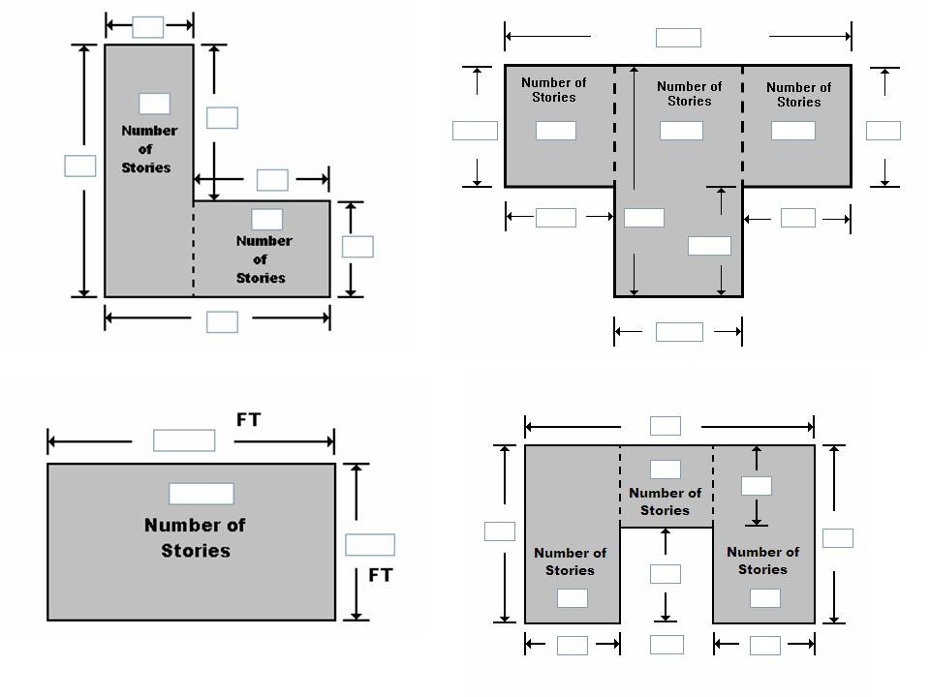

COST Tab

Base Cost per Sq Ft: Geographic Adjustment:

Adjustments
Single-Family House | Quantity | Units | Unit Cost | Item Cost
Roofing |  | Sq Ft
Heating / Cooling |  | Each
Appliances |  | Each
Fireplaces |  | Each
Porch / Breezeways |  | Sq Ft
Garage |  | Sq Ft
Manufactured House | Quantity | Units | Unit Cost | Item Cost
Expando |  | Sq Ft
Carport |  | Sq Ft
Open Porch |  | Sq Ft
Enclosed Porch |  | Sq Ft
Decks |  | Each
Skirting |  | Sq Ft
Fireplaces |  | Each

COST Tab
Additional Adjustments
Adjustments | Quantity | Unit Cost | Item Cost

Cost Data Reference (source or name):

Cost Data Date:

Depreciation Rating:
1. Very Poor Condition 2. Requires Extensive Repairs 3. Requires Some Repairs
4. Average Condition 5. Above Average Condition 6. Excellent Condition 7. Other
Depreciation Percentage (if ‘Other’ selected for Depreciation Rating):
Depreciation Explanation (if ‘Other’ selected for Depreciation Rating):

Element Percentages Tab
Element Percentages
Residence Type: Single-Family (SF) House Manufactured House (MH)

Item | % Damaged | Element % | Item Cost | Damage Values
Foundation (SF only)
Superstructure
Roof Covering
Exterior Finish
Interior Finish
Doors and Windows
Cabinets and Countertops
Flood Finish
Plumbing
Electrical
Appliances
HVAC
Skirting / Forms Piers (MH only)

SDE OUTPUT SUMMARY Tab - Optional User Entered Data
Professional Market Appraisal:
Tax Assessed Value: Factor Adjustment: Adjusted Tax Assessed Value:
Contractor’s Estimate of Damage:
Community’s Estimate of Damage:

